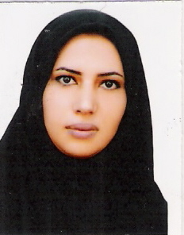
دکتر بنت الهدی مهدی زاده
درجه علمی: دکتری مهندسی پزشکی
09132439989 | تلفن همراه
03433423985 | تلفن
03433425400 | فاکس
Hoda.mehdizadeh88@gmail.com | ایمیل

Hoda mehdizadeh

Personal Information
last name mehdizadeh
firstname hoda(bentolhoba)
Date of birth 30st oct 1986
Gender Female
Marital status Married
Address Faculty of Nursing zarand, University of Medical Sciences, Kerman, Iran
E-mail hoda.mehdizadeh88@gmail.com
Mobile +98 913 243 9989
Work Phone +98 34 33423985
Fax +98 34 33425400

Education
Phd Medical Engineering, Islamic Azad University, South Tehran Branch, Tehran Iran
MSc Medical Engineering, Ferdowsi University of Mashhad, Mashhad, Iran
BSc Electrical Engineering, Islamic Azad University of kerman,kerman, iran

Practical and academic Experiences
[1] 2015: Investigation of thermal distribution for pulsed laser radiation in cancer treatment with nanoparticle-mediated hyperthermia
[2] 2018: Introduction to nanocarriers and their applications in drug delivery, reviews
[3] 2019: The optimisation of operating parameters of dye removal: application of designs of experiments
[4] 2019: Synthesis of zero-valent Iron nanoparticles for ultrasonic assisted dye removal: Modeling and optimization
[5] 2019: Removal of crystal violet using nanozeolite-x from aqueous
solution: Central composite design optimization study
[6] 2019: Experimental design and modelling of removal of dyes using nano-zero-valent iron: a simultaneous model

